
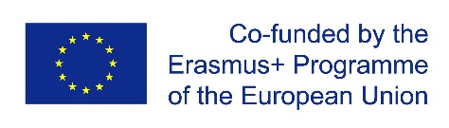

Role of Universities in the Regional Development
RURD

The aim of the project is to make Georgian regional HEIs more relevant to the communities and regions they are located and to serve as a basis for regional development.

Objectives of the project are:
•to develop mission, vision and strategic development plans for regional universities based on SWOT analysis and local needs analysis in cooperation with local authorities and social partners
•to increase cooperation between Universities and Local Government Authorities to increase their capacity and enhance specification of each region
•to improve and modernize the management structures in universities of Georgia and make their administrative structures compatible with those of the European universities by gathering and sharing best practices from EU Partners

GEORGIAN PARTNER HEIs: 9 regional universities
- Akaki Tsereteli State University (Georgia) (Coordinator)
- Kutaisi University (Georgia)
- Batumi Shota Rustaveli State University (Georgia)
- Batumi State Maritime Academy (Georgia)
- Batumi Arts State University (Georgia)
- Shota Meskhia State Teaching University of Zugdidi (Georgia)
- Gori State Teaching University (Georgia)
- Iakob Gogebashvili Telavi State University (Georgia)
- Samtskhe-Javakheti State University (Georgia)
- Caucasus University (Georgia)

EU PARTNERS
- University of Santiago de Compostela (Spain)
- FH JOANNEUM Gesellschaft mbH (Austria)
- Masaryk University (Czech Republic)
- Vytautas Magnus University (Lietuva)

GOVERNMENT / NON HEI PARTNERS
- Ministry of Education, Science, Culture and Sport of Georgia (Georgia)
- National Center for Educational Quality Enhancement (Georgia)

For more information, please visit http://rurd.atsu.edu.ge/
https://www.facebook.com/Role-of-Universities-in-the-Regional-Development-RURD-106946334525586/?ref=page_internal

