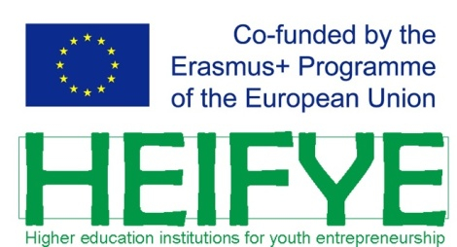 | 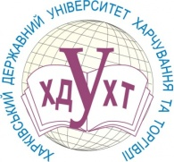  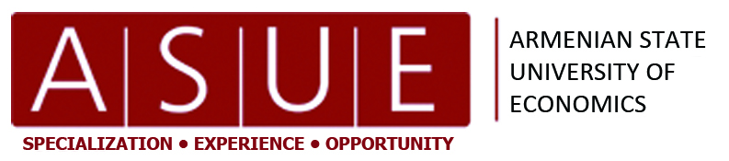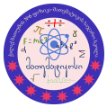

Batumi Shota Rustaveli State University (Georgia)
Kharkov State University of Food Technology and Trade (Ukraine)
Armenian State University of Economics (Armenia)
Belarusian Trade and Economics University of Consumer Cooperatives (Belarus)
Technical University of Moldova (Moldova)
Academy of Economic Studies of Moldova (Moldova)
University of RISEBA (Latvia)
International Academy of Science and Informatics (МАНИО)
Batumi Public School of Physics and Mathematics (Georgia)

International Scientific and Practical Conference

« Youth Entrepreneurship in the Eastern Partnership Countries: the Experience of Formation and Prospects for Development»
The project is carried out within Erasmus + program (http://heifye.hduht.edu.ua)"Higher educational institutions for youth entrepreneurship".

September 13-14, 2018
(Batumi, Georgia)

The Organizing Committee invites you to participate in the International Scientific and Practical Conference "Youth Entrepreneurship in the Eastern Partnership Countries: the Experience of Formation and Prospects for Development", which will be held in Batumi, September 13-14, 2018 at Batumi Shota Rustaveli State University.

Scientific Themes

- Youth Entrepreneurship: Role, Experience, Problems and Prospects of Development in the Eastern Partnership Countries;
- Institutional, juridical, organizational, financial and social backgrounds for the development and support of youth entrepreneurship in the countries of the Eastern Partnership;
- Innovative methods and programs supporting the entrepreneurial initiative of youth: the experience of the EU countries and the Eastern Partnership;
- The experience of EU countries for the development of the entrepreneurial ecosystem in the countries of the Eastern Partnership;
- Place and role of the educational system in the development of youth entrepreneurship. Youth entrepreneurship and informational technology;
- The role of social entrepreneurship in the economic development of the Eastern countries.

Important dates:

Beginning of the applications submission is on | the 1st of May 2018
Deadline for the Applications is on | the 10th of July 2018
Report on the acceptance (rejection) of the applications is on | the 15th of July 2018
The conference will be held on | the 13 – 14th of September 2018

THE OFFICIAL LANGUAGES OF THE CONFERENCE ARE English, Georgian, Russian.

INTERNATIONAL PROGRAM COMMITTEE

Merab Khalvashi | Rector of Batumi Shota Rustaveli State University (Georgia), Chairman;
Victoria Grosul | HEIFYE Project Coordinator, Kharkov State University of Food Technology and Trade (Ukraine), Deputy Chairman;
Ibraim Didmanidze | Manager of the HEIFYE project, Batumi Shota Rustaveli State University (Georgia), Chairman;
Zurab Megrelishvili | Batumi Shota Rustaveli State University (Georgia), Deputy Chairman;
Alexander Cherevko | Rector of Kharkov State University of Food Technology and Trade (Ukraine);
Koryun Atoyan | Rector of Armenian State University of Economics (Armenia);
Viorel Bostan | Rector of Technical University of Moldova (Moldova);
Svetlana Lebedeva | Rector of Belarusian Trade and Economics University of Consumer Cooperatives (Belarus);
Gregory Belostechnik | Rector of Technical University of Moldova (Moldova);
Irina Sennikova | Rector of University of RISEBA (Latvia);
Sergey Zubkov | Kharkov State University of Food Technology and Trade (Ukraine);
Diana Galoyan | Armenian State University of Economics (Armenia);
Tatyana Bukos | Academy of Economic Studies of Moldova (Moldova);
Irina Trusevich | Belarusian Trade and Economics University of Consumer Cooperatives (Belarus);
Natalia Yatsevich | Belarusian Trade and Economics University of Consumer Cooperatives (Belarus);
Rafael Chiloci | Technical University of Moldova (Moldova);
Ilmars Creutuss | Rector of University of RISEBA (Latvia);
Juris Asars | Rector of University of RISEBA (Latvia);
Natia Tsiklashvili | Batumi Shota Rustaveli State University (Georgia);
Tamar Siradze | Batumi Shota Rustaveli State University (Georgia);
Jemal Ananidze | Batumi Shota Rustaveli State University (Georgia);
Anzor Beridze | Batumi Shota Rustaveli State University (Georgia);
Madona Mikeladze | Batumi Shota Rustaveli State University (Georgia);
Таtia Nakashidze-Makharadze | Batumi Shota Rustaveli State University (Georgia);
Guram Chachanidze | International Academy of Science and Informatics (Georgia)
Ketevan Nanobashvili | International Academy of Science and Informatics (Georgia)
Zurab Zakaradze | Batumi Public School of Physics and Mathematics (Georgia).

ORGANIZING COMMITTEE

Merab Megrelishvili | Batumi Shota Rustaveli State University (Georgia), Chairman;
Nelly Akhvlediani  Giorgi Imnaishvili | Batumi Shota Rustaveli State University (Georgia), Chairman;  Batumi Shota Rustaveli State University (Georgia), Deputy Chairman;
Didar Didmanidze | Batumi Shota Rustaveli State University (Georgia), Secretary.
Mikheil Donadze |  | Nino Samnidze | Zeinab Akhvlediani
Temur Turmanidze |  | Iulia Gorjeladze | Ia Motskobili
Otar Janelidze |  | Medea Diasamidze | Rima Tkhilaishvili
Indico Abashidze |  | Teona Tedoradze | Grigol Kakhiani
Maia Takidze |  | Darejan Geladze | Leila Diasamidze
Zebur Beridze |  | Natalia Robitashvili | Nino Khudzhadze
Marina Didmanidze |  | Zurab Dumbadze | Gulnaz Diasamidze
Ekaterine Jincharadze |  | Omar Givradze

THE SECRITARIAT OF THE PROGRAMMING AND ORGANIZING COMMITTEE

6010, Batumi, Georgia, 35 Ninoshvili Street,. Batumi Shota Rustaveli State University, room 408.
Phone. +995 599 27 66 00 +995 593 30 59 74 +995 57999 97 18
e-mail: heifye.konf@gmail.com
Website: www.heifye.org

CONFERENCE PUBLICATIONS

To participate in the conference, it is necessary to send the applications in e-form (the form is attached) and the reports (in Russian or English), issued in accordance with the rules (the example is attached) to heifye.konf@gmail.com before July 10, 2018. The Organizing Committee will confirm the receipt of an application and a report.
Prior to the conference, the accepted materials will be published in the Digest of the Conference articles in e-form.
According to the results of the reports, the works selected by the program committee (O/R of the authors) can be published in the journals INTELECTI (ISSN 1512-0333), Journal of Business Management (ISSN 1691-5348).
If necessary, accommodation will be provided (hotel-type rooms) and an invitation to the conference will be sent. The date and time of the presentations at the conference will be agreed with the participants.
We will be glad to support the participants of the conference.

The Organizing Committee of the Conference

