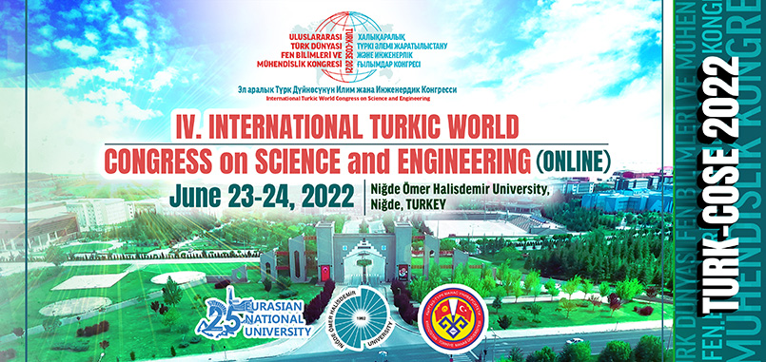
http://www.ohu.edu.tr/turk-cose-tr
http://www.ohu.edu.tr/turk-cose-kz
http://www.ohu.edu.tr/turk-cose-kg
http://www.ohu.edu.tr/turk-cose-en

Dear TURK-COSE Participants,

The 4rd International Turkic World Congress on Science and Engineering, TURK-COSE, will be held with ONLINE participation in Nigde, Turkey on 23-24 June 2022, organized by L.N. Gumilyov Eurasian National University (ENU), Kyrgyz-Turkish Manas University (KTMU), and Niğde Ömer Halisdemir University (NOHU), Turkey. TURK-COSE 2022 focuses on Information & Telecommunication Technologies, Natural and Applied Sciences, Physics &Technical Sciences Material Sciences, Building Technologies & Engineering Agricultural Sciences and topics ranging from Contemporary Sciences, Engineering and Technology to Transportation & Energy.

We are looking forward to welcoming you TURK-COSE 2022 for a successful and efficient Congress.
Best Regards,

Prof. Dr. Murat Barut
NOHU, Turkey
Acting Co-Chair

Click for Turkish Call For
Click for Kazakh Call For
Click for Kyrgyz Call For
Click for English Call For

IMPORTANT NOTES:
• The official languages of TURK-COSE 2022 are; Turkish / Kazakh / Kyrgyz / English / Russian.
• Speakers from at least 5 different countries will participate and make ONLINE presentations.
• The accepted, registered and presented papers of full texts and abstracts will be published in the BOOK of PROCEEDINGS numbered with the ISBN and in the BOOK of ABSTRACTS respectively.
• Extended / revised version of the proceedings in English selected by TURK-COSE 2022 Regulatory Board in the Special Issue of Eurasian Journal of Science, Engineering, and Technology (https://dergipark.org.tr/en/pub/ejset) will be proposed for publication.
• Participation in the Congress with or without paper is FREE OF CHARGE.

IMPORTANT DATES:
Deadline for Abstract Submission: 8 May (Sunday) 2022
Deadline for Full Text Submission: 8 May (Sunday) 2022
Deadline for Notification of Acceptance: 15 May (Sunday) 2022
Deadline for Camera Ready Abstract and Full Text Submissions: 22 May (Sunday) 2022
Deadline for Author Registration: 22 May (Sunday) 2022
Congress Dates: 23 (Thursday)-24 (Friday) June 2022

